Game Theme: Zombie Apocalypse

Image:

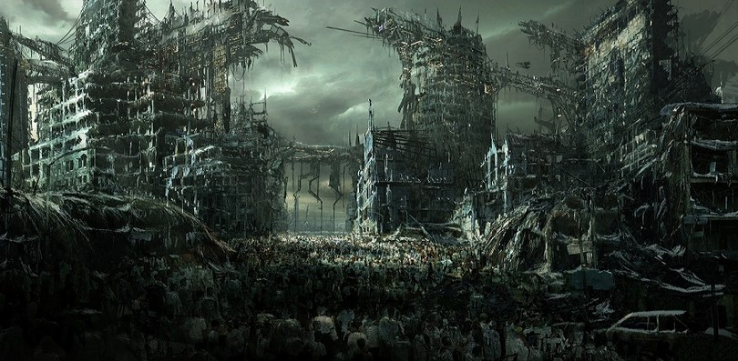



Who is the player: John Wick

Goal: Find his zombie dog